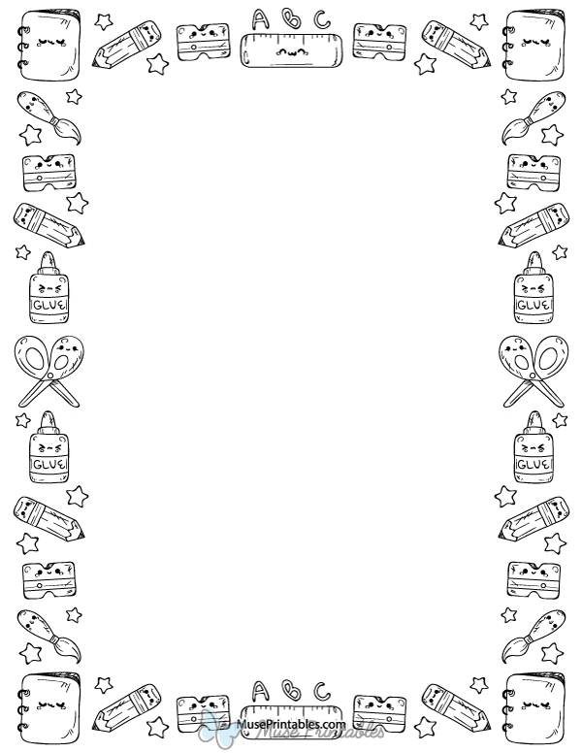

**Most Needed Classroom Supplies**

Tissue, colored copy paper, white copy paper, cardstock, watercolor paints, paintbrushes, vis-à-vis markers, glue sticks, glue sticks, glue sticks!

**First Grade Suggested Supply List**

* Backpack (no wheels)
* 3 primary composition books
* 3 different colored highlighters
* Plastic 5x8 pencil box
* 1 pkg sheet protectors
* 2 sticks of glue (daily)
* 1 Fine Point black Sharpie
* 1 Box of 8 Crayola markers
* 1 pkg of Expo Markers
* 4 plain pocket folders with 3 prongs (plastic)
* 4 #2 pencils (daily)
* I pkg of eraser toppers
* 2 pkgs 3x3 Post-it notes
* 1 box of sandwich

Ziplock baggies

* 1 box of gallon Ziplock baggies
* I box of tissue
* 1 pkg of baby wipes